WEB-BASED GEOGRAPHICAL INFORMATION SYSTEM (WEB GIS) FOR RECREATIONAL AND SPORTS FACILITY MAPPING
USER GUIDE
Web-Based Geographic Information System (Web GIS) for Recreational and Sports Facility Mapping – Unguja Island, Zanzibar.
- Introduction
This user guide provides step-by-step instructions on how to use the Web-Based Geographic Information System (Web GIS) developed for mapping recreational and sports facilities in the Unguja Island, Zanzibar.
The system allows users to visualize spatial data, interact with the map, view facility information, and control different map layers through a web browser.
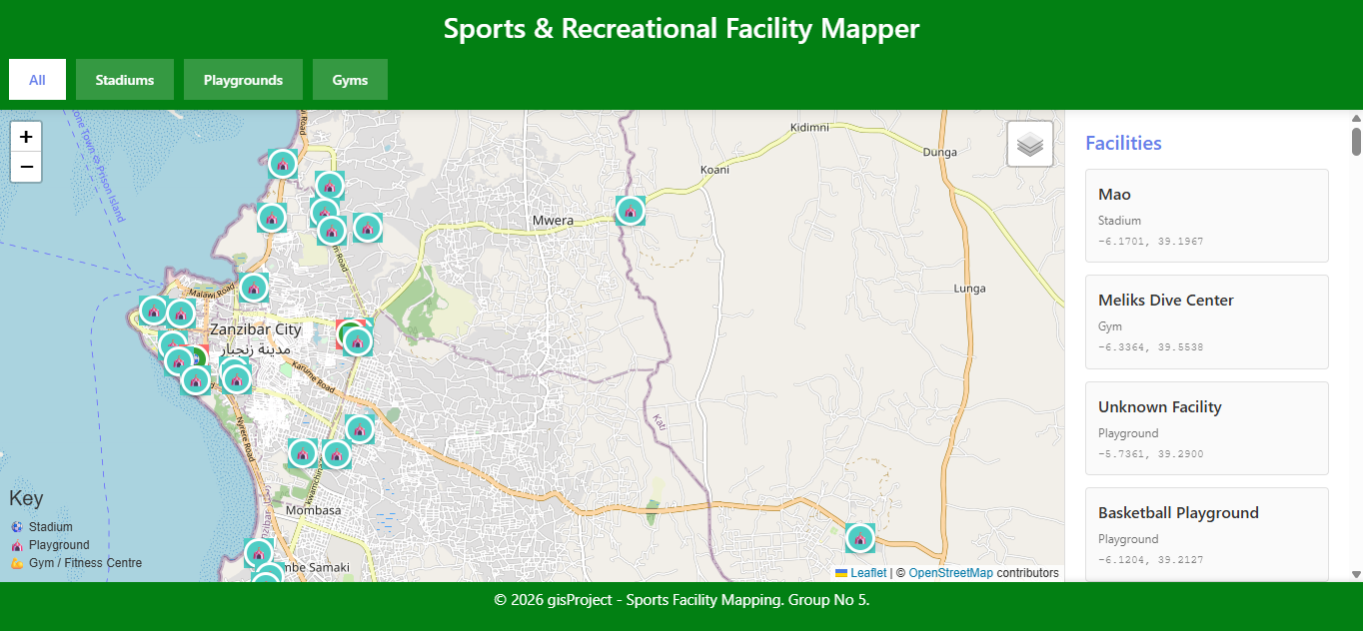
- System Requirements
To use this Web GIS application, the user needs:
A computer, tablet, or smartphone
A modern web browser (Google Chrome, Mozilla Firefox, Microsoft Edge, or Safari)
Internet connection (if using online map tiles) or offline setup with local files
- How to Open the Application
Step 1:
Locate the project folder named:
Webgis

Step 2:
Open the file named:
Index.html
Step 3:
Double-click the file or right-click → Open with → Choose your web browser.
The Web GIS map interface will load automatically.
- Understanding the Map Interface
The Web GIS interface contains the following components:
Map Display Area: Shows the spatial layers and base map.
Zoom Controls (+ / –): Used to zoom in and out.
Layer Control Panel: Used to turn layers on or off.
Pop-up Information Box: Displays attribute information when features are clicked.
Map Title: Displays the project title at the top of the page.
- Map Navigation
Zooming:
Click + to zoom in
Click – to zoom out
You can also use the mouse scroll wheel
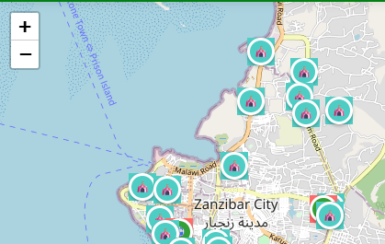
Panning:
Click and hold the left mouse button
Drag the map in any direction

- Layer Control
The layer control panel allows users to manage map layers.
Available Layers:
Administrative Boundaries
Road Network
Sports Facilities
To Turn Layers ON/OFF:
Tick the checkbox to show a layer
Untick the checkbox to hide a layer
This allows users to view only the information they need.
- Viewing Feature Information (Pop-ups)
To view information about a sports facility:
Click on any point feature on the map.
A pop-up window will appear displaying:
Facility name
Facility type
Ownership
This helps users quickly identify and understand each facility.
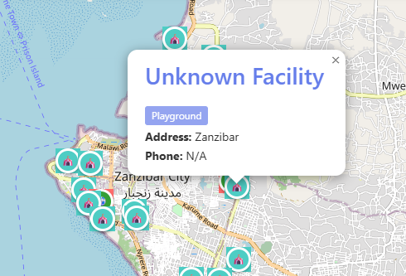

- Understanding Map Symbols
Feature Type
Symbol Description
Sports Facility
Point marker
Roads
Blue line
Administrative Boundary
Black polygon border
- Typical User Tasks
Task 1: Find a Sports Facility
Zoom into the required area
Turn on Sports Facilities layer
Click on markers to view details
Task 2: View Road Network
Turn on Road Network layer
Zoom and pan to analyze road connectivity
Task 3: View Administrative Areas
Turn on Administrative Boundaries layer
Observe ward and district boundaries
- Troubleshooting
Problem | Solution
Map not loading | Check internet connection or reload page
Layers not showing | Ensure layer checkbox is selected
Blank screen | Refresh browser or reopen index.html
Slow loading | Close other applications or reduce zoom level

- Conclusion
This Web GIS application provides an easy-to-use platform for visualizing and exploring recreational and sports facilities in Unguja Island. The system supports planning, decision-making, and public access to spatial information through interactive mapping.

